IT Technologies

# Jess – Natural Language Processing and Chatterbots

1. What does it do? (600 words) What is the state of the art of this new technology? What can be done now? What is likely to be able to do be done soon (say in the next 3 years)? What technological or other developments make this possible?
2. What is the likely impact? (300 words) What is the potential impact of this development? What is likely to change? Which people will be most affected and how? Will this create, replace or make redundant any current jobs or technologies?
3. How will this affect you? (300 words) In your daily life, how will this affect you? What will be different for you? How might this affect members of your family or your friends?

# Natural Language Processing and Chatterbots - Intro

These days the demand for ease of access to information and faster response times often exceeds the capacity of human workforce, to address this issue organisations have taken advantage of modern technology to perform the monotonous task of answering frequently asked questions. Artificial intelligence software programs known as chatterbots, are designed to replicate human dialogue so that they can be used to respond to consumer enquiries in natural human language, meaning that the consumer is lead to believe that they are actually conversing with a real person.

The term ‘Chatterbot’ was coined in 1994, however it’s origins began as early as 1964 when Joseph Weizenbaum created the first version of a chatterbot at MIT Artificial Intelligence Laboratory, which he named ELIZA.  ELIZA worked by using pattern matching and would identify key words in the sentence and respond using pre-determined responses.  It was in 1995 that natural language processing was first used with a chatterbot to produce a more organic dialogue between computer and human, this adaptation was named ALICE.  Since ALICE there has been an ever-increasing number of chatterbot platforms developed and used by various industries to complement their business processes. The internal process for all chatterbots essentially consists of three stages which include input, analysis of the input which identifies best response options and the return of the best response as outlined in the below diagram.

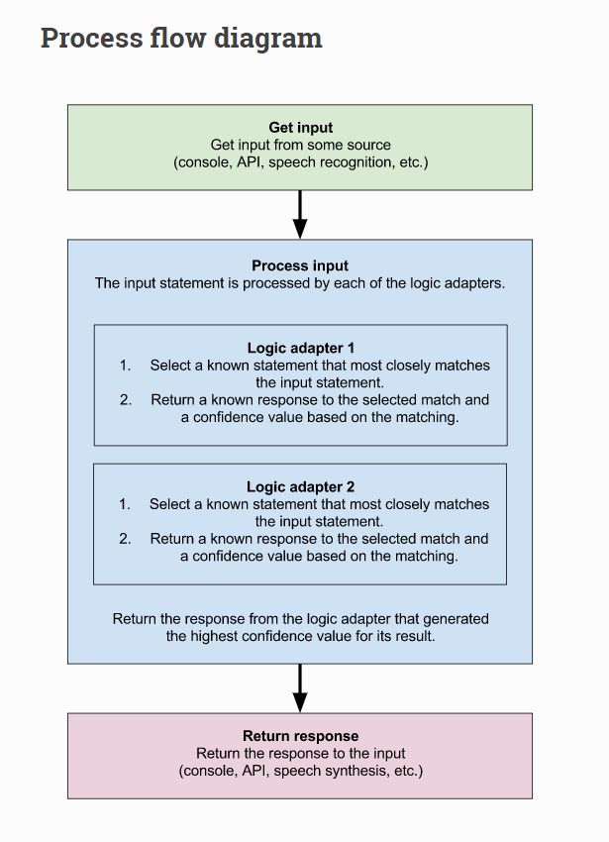

(Source: <https://chatterbot.readthedocs.io/en/stable/>)

There are a number of approaches to the functionality for chatterbots which include pattern matching, algorithms and artificial neural networks. The simplest of these is the pattern matching version of the software, as mentioned earlier pattern matching would identify key words and draw their response from pre-defined options, for example banking institutions have an automated answering service that asks the customer to provide a set phrase in order to filter their call and if the caller tries to deviate the bot will not recognise the request and ask the user to re-enter the query. The more common application of chatterbots uses a more intuitive method which employs artificial intelligence software known as Natural Language Processing and depends on the complexity of the input the chatterbot will be expected to process. Chatterbots that run using NPL can handle anything from a frequently asked question on a website, to holding a conversation through a messenger service like Facebook Messenger or even sifting through the internet to locate the best response to any question that is posed e.g. Siri or Google Assistant.

Natural Language Processing (NLP) is a multi-field study consisting of linguistics, computer science, information engineering, and artificial intelligence. However in the computer science aspect of NLP the objective is for the computer software to learn human natural language nuances by reading, analyzing and deciphering the intention behind words and sentences.

# Natural Language Processing and Chatterbots - Current Application

Have you recently visited a website for a service provider and found yourself closing the chat window invitation without giving it much thought, this automatic pop-up is most likely a chatterbot that has been embedded in the website. Chatterbot deployment is found on almost any website nowadays and as previously mentioned is being utilised for a range of activities from answering frequently asked questions to messenger services that might discuss politics or provide mental health and wellbeing assistance, the range of applications is quite extensive. Due to the popularity of chatterbots there is a multitude of platforms available to create, deploy and manage bots. According to a range of sources some of the best platforms on the market include IBM Watson Assistant, Flow XO and Botsify. IBM Watson Assistant is most frequently listed in the top ten best AI Chatbot platforms and has been described as being flexible enough to be applied from a small business to enterprise level, “it allows collaboration between business SMEs and developers to build out conversational solutions and advanced dialog flows, without needing to be an expert in machine learning’ (G2 n.d.).

# Natural Language Processing and Chatterbots – Potential Application/Development

# Natural Language Processing and Chatterbots – Impact

* Reduction of workforce demand for call centre/help desk staff
* Improved customer relationships due to increased efficiency in responding to queries
* Potential for increased customer recruitment and retention with the deployment of chatterbots on websites giving illusion that company has outstanding customer service
* As an individual if chatterbot works well it will improve user experience by allowing customer to quickly find answers

**Reference List:**

G2 n.d., *IBM Watson Assistant Reviews & Product Details,* viewed 6 October 2019, <https://www.g2.com/products/ibm-watson-assistant/reviews>